**CSE320: Data Communications**

**Quiz-03 (Set – B)**

**Total Marks: 20**

**Name: ID: Sec:**

1. For the following Multi-level ASK, find the bit stream form the signal below: [4]

| | Bit Pattern | Amplitude | | --- | --- | | 00 | 0V | | 01 | 3V | | 10 | 1V | | 11 | 4V | |  |
| --- | --- | --- | --- | --- | --- | --- | --- | --- | --- | --- | --- |

2. Draw the analog signal for the digital bit stream 110100011011 using Multi-level FSK where 2 bits at a time get transmitted. [Amplitude of the Carrier Signal = 4V and phase = 0 rad, Number of Cycles of the signal element for different Bit Patterns: 00: 1, 01: 3, 10: 4, 11: 2] [4]

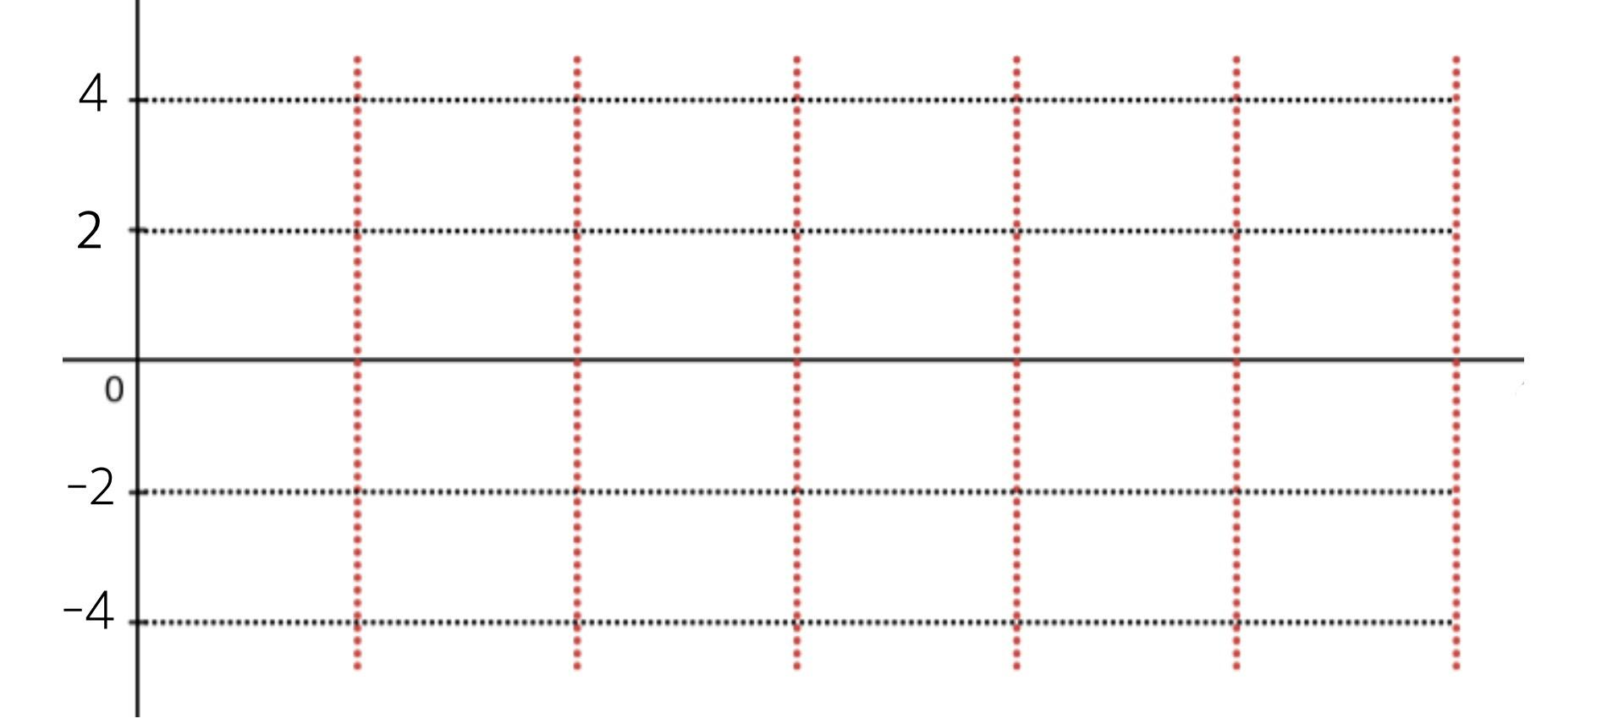

3. Draw the analog signal for the bit stream 0111001110 using the constellation diagram given below [frequency = 2 for each signal element and amplitude = 4V] [4]

|  |  |
| --- | --- |

4. Which digital to analog modulation technique is the most susceptible to noise? Justify your answer. [4]

5. Draw the constellation diagram for the following cases. Find the peak amplitude value for each case and define the type of the modulation (ASK/ FSK/ PSK). The numbers in parentheses define the values of I (In-phase Carrier) and Q (Quadrature Carrier) respectively. [2 + 2 = 4]

(a) Two points at (3, 0) and (5, 0)

(b) Two points at (0, 4) and (0, -4)

